Genomic and transcriptomic survey of an endophytic fungus Calcarisporium arbuscula and potential overview of its secondary metabolites
Jin-Tao Cheng^{1,2}, Fei Cao^{1,2}, Xin-Ai Chen^{1,2}, Yong-Quan Li^{1,2}*, Xu-Ming Mao^{1,2}*

¹Institute of Pharmaceutical Biotechnology, School of Medicine, Zhejiang University, Hangzhou 310058, China
²Zhejiang Provincial Key Laboratory for Microbial Biochemistry and Metabolic Engineering, Hangzhou 310058, China.

*To whom correspondence should be addressed:
Prof. Xu-Ming Mao, E-mail: xmmao@zju.edu.cn; Tel: 86-571-88981335; Fax: 86-571-88208569.
Prof. Yong-Quan Li, E-mail: lyq@zju.edu.cn; Tel: 86-571-88206632; Fax: 86-571-88208569.

Fig. S1 Statistics analysis for subread of C. arbuscula clean data
a Sequencing read length of clean data. The left vertical and the right vertical represent the Subread length, number of Subread at specified length.
b Mass distribution of clean data. The abscissa indicates the quality of the sequencing, the column bar corresponds to the left ordinate, and the left ordinate indicates the number of reads corresponding to the sequencing quality.

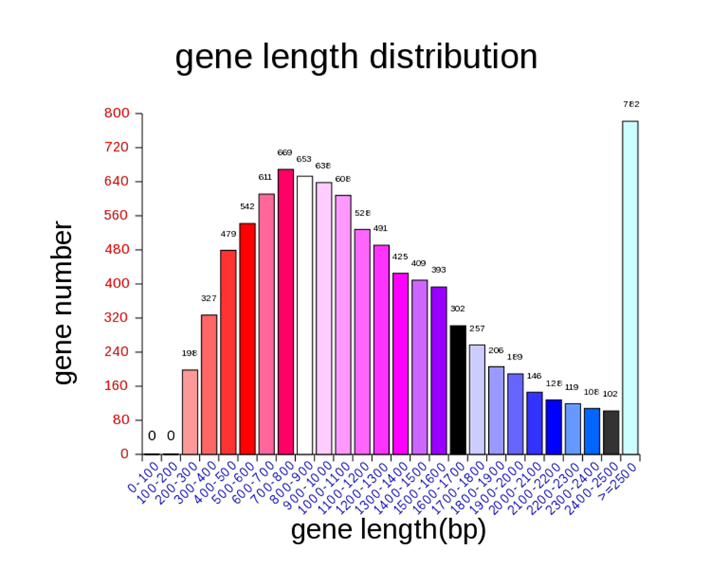

Fig. S2 Statistics analys for gene length distribution of C. arbuscula clean data

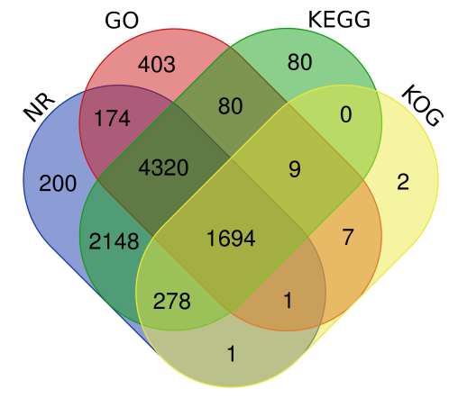

Fig. S3 Venn-plot distribution of coding genes by four databases

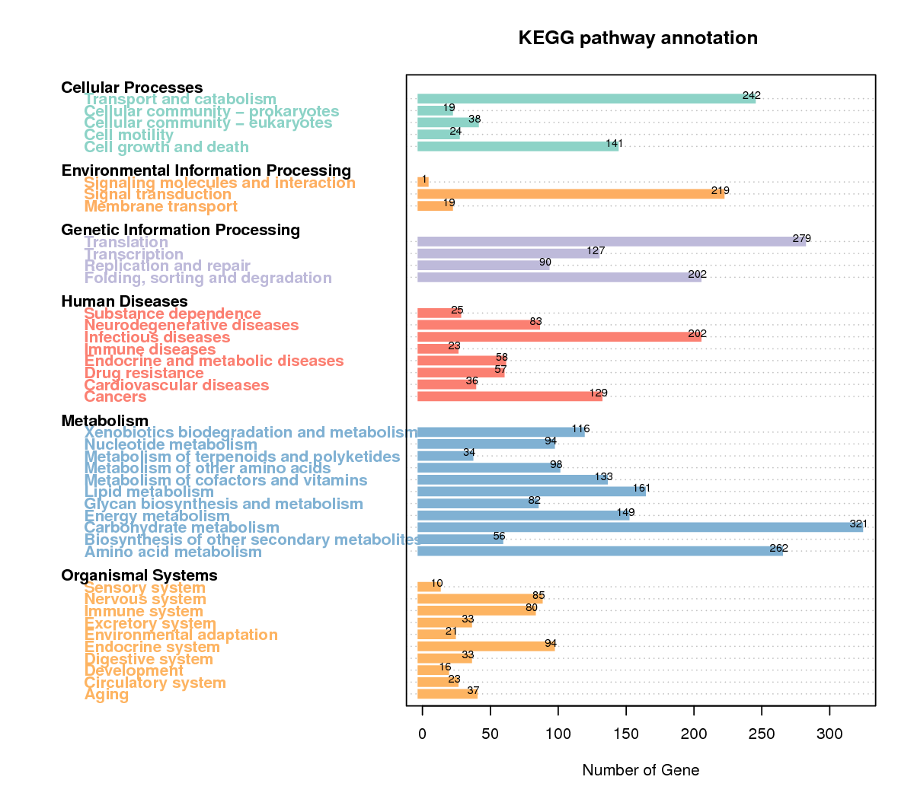

Fig. S4 Histogram of KEGG distribution of predicted proteins of C. arbuscula

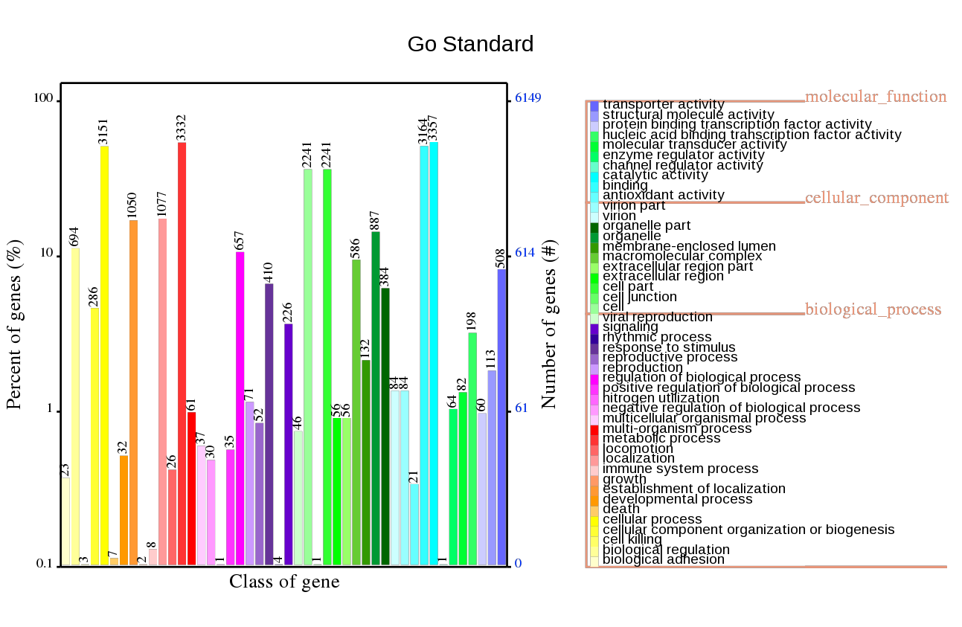
Fig. S5 Histogram of GO distribution of predicted proteins of C. arbuscula

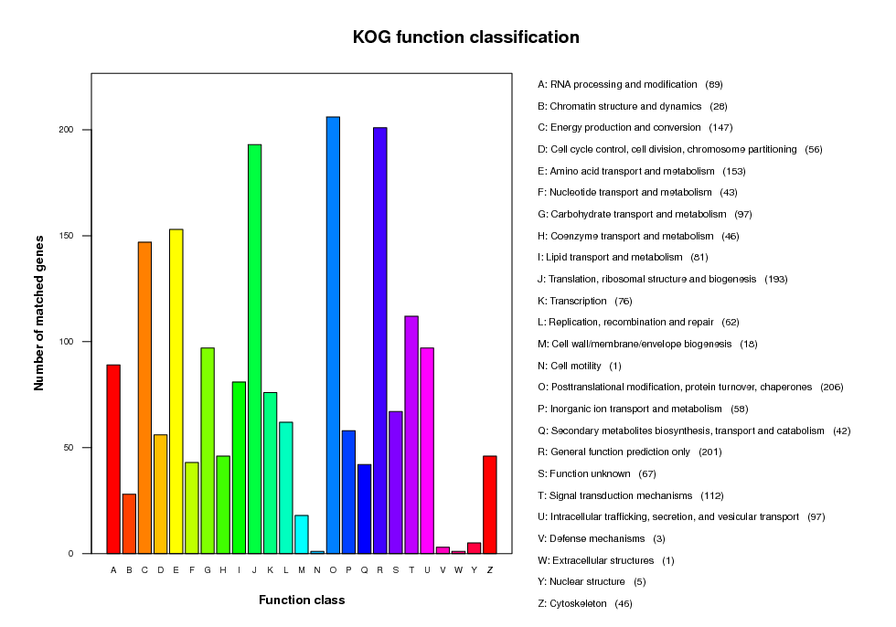
Fig. S6 Histogram of KOG distribution of predicted proteins of C. arbuscula

Fig. S7 Sporulated mycelium of C. arbuscula on PDA plate after 5-day-culture at 25 °C.
a Spore mycelium of C. arbuscula on PDA plate after 5-day-culture at 25 °C from the front of the plate. b Spore mycelium of C. arbuscula on PDA plate after 5-day-culture at 25 °C from the reverse side of the plate.

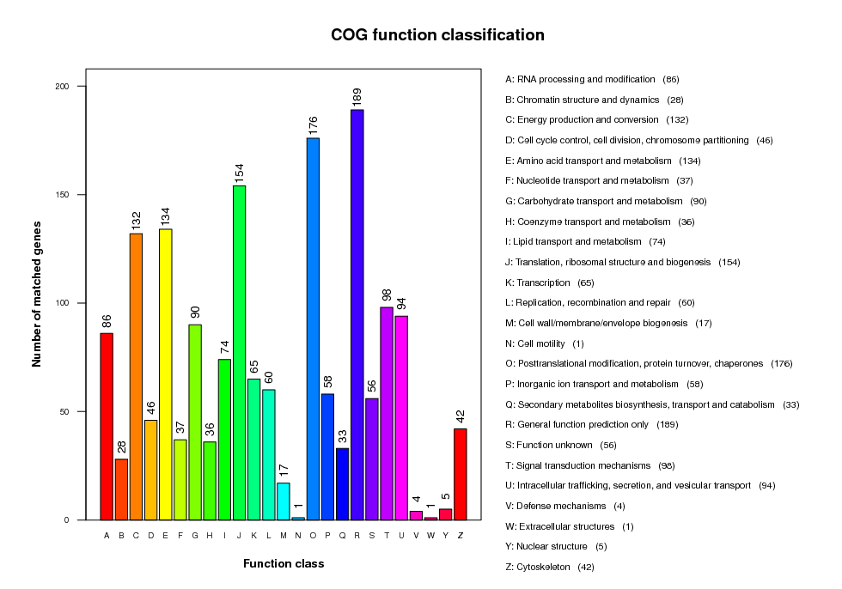
a

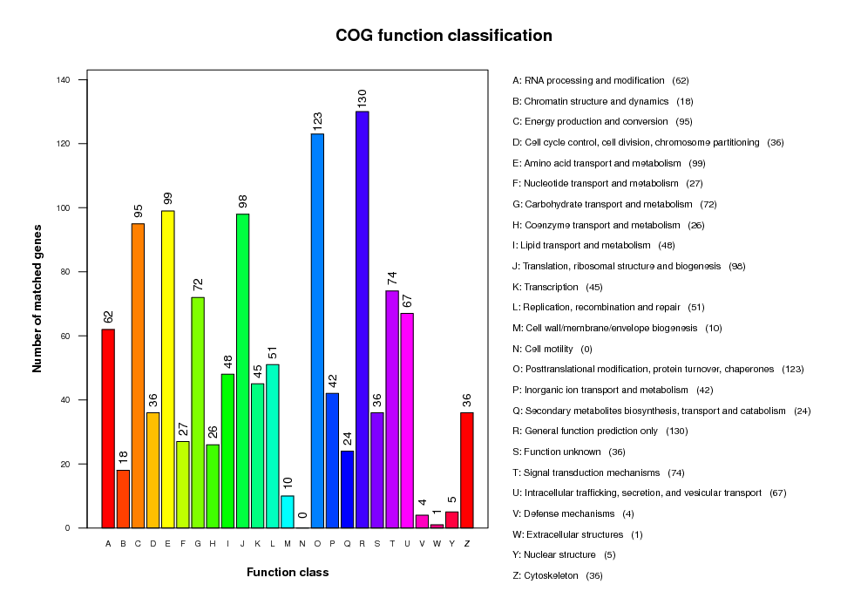

b

Fig. S8 Histogram of COG annotation of nucleotide motif sequences recognized by methyltransferase. a) COG annotation of nucleotide motif sequences CGD recognized by methyltransferase. b) COG annotation of nucleotide motif sequences CAWTC recognized by methyltransferase

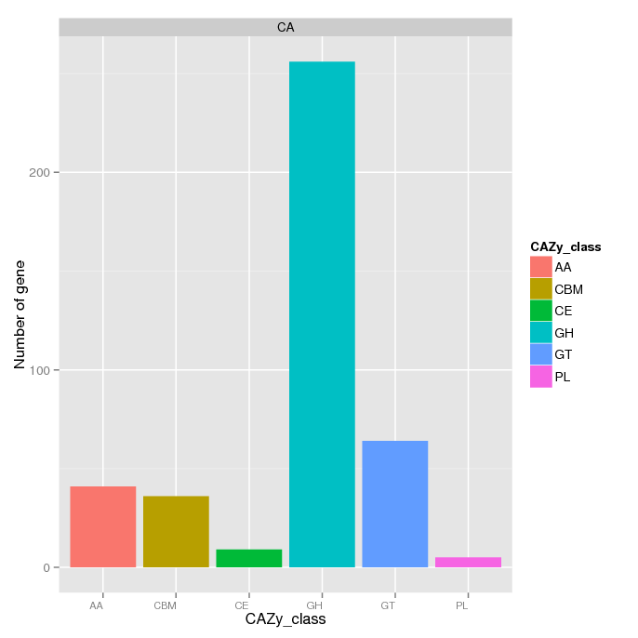

Fig. S9 Histogram of CAZymes distribution of predicted proteins of C. arbuscula

